## 2. Installation Guides

### 2.1 System Requirements

**Hardware Requirements:**

* Processor: Quad-core 2.4 GHz or higher (Intel i5 or equivalent recommended for Android Studio)
* Memory (RAM):
  + Minimum: 8 GB
  + Recommended: 16 GB (especially for Android Studio)
* Storage:
  + Minimum: 20 GB of free disk space
  + Recommended: More space may be required.

**Software Requirements:**

* Operating System: Windows 10/11, macOS 10.15 or later, or a Linux distribution (e.g., Ubuntu 20.04+)
* Node.js: Version 14.x or later
* npm (Node Package Manager): Version 6.x or later
* Android Studio: Ladybug or at least 3.0
* Visual Studio Code: any version (latest preferable)
* Flutter/Dart SDK: at least version 3.5.3
* A web browser: Chrome, Firefox, Safari, or Edge

**Relevant Configurations:**

* Environment variables configured for database connections and application settings
* Android Studio / Visual Studio Code require installation and configuration.
* Flutter/Dart SDK path requires configuration.

### 2.2 Installation Instruction

* **Android Mobile App:**

Link to the demo video: [How to install front-end module of project (Android Mobile)](https://youtu.be/-66LH0C6xps)

1. Install Flutter SDK from the following link:[Install | Flutter](https://docs.flutter.dev/get-started/install)

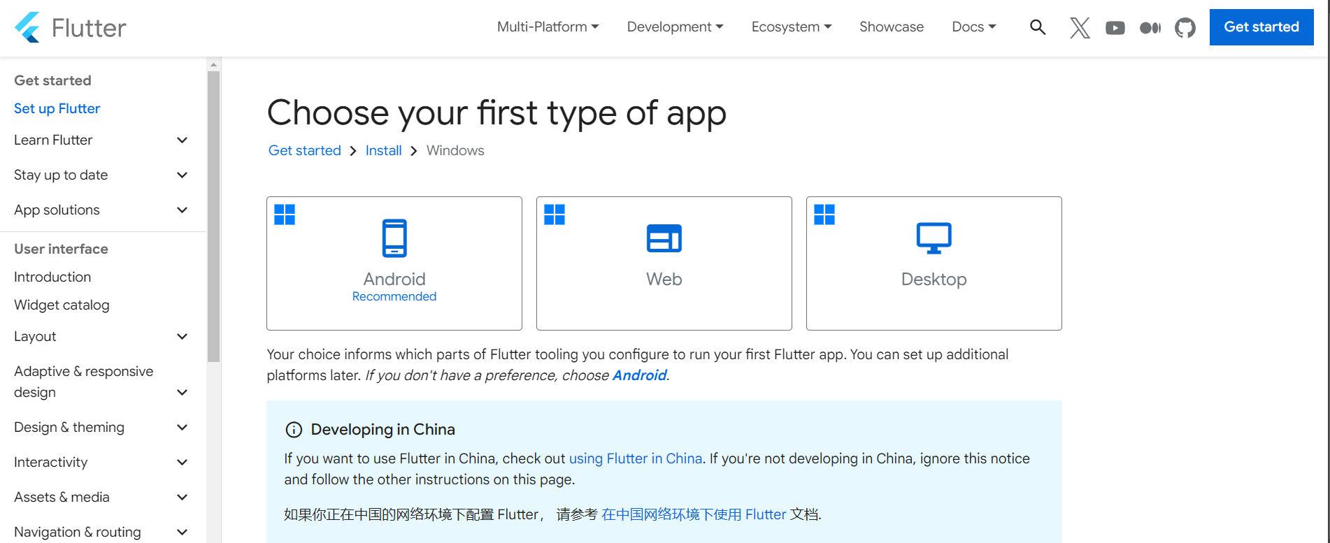

1. Setup Flutter SDK according to the instructions.

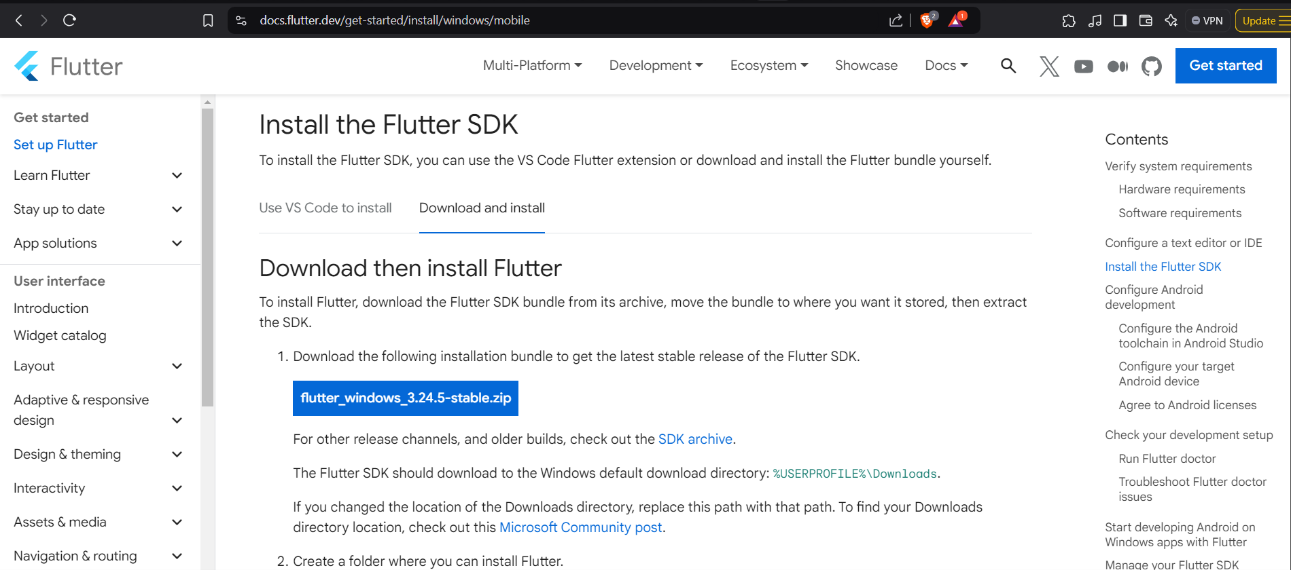

1. Install Android studio from: [Download Android Studio & App Tools - Android Developers](https://developer.android.com/studio) or using this terminal command: “winget install -e --id Google.AndroidStudio”

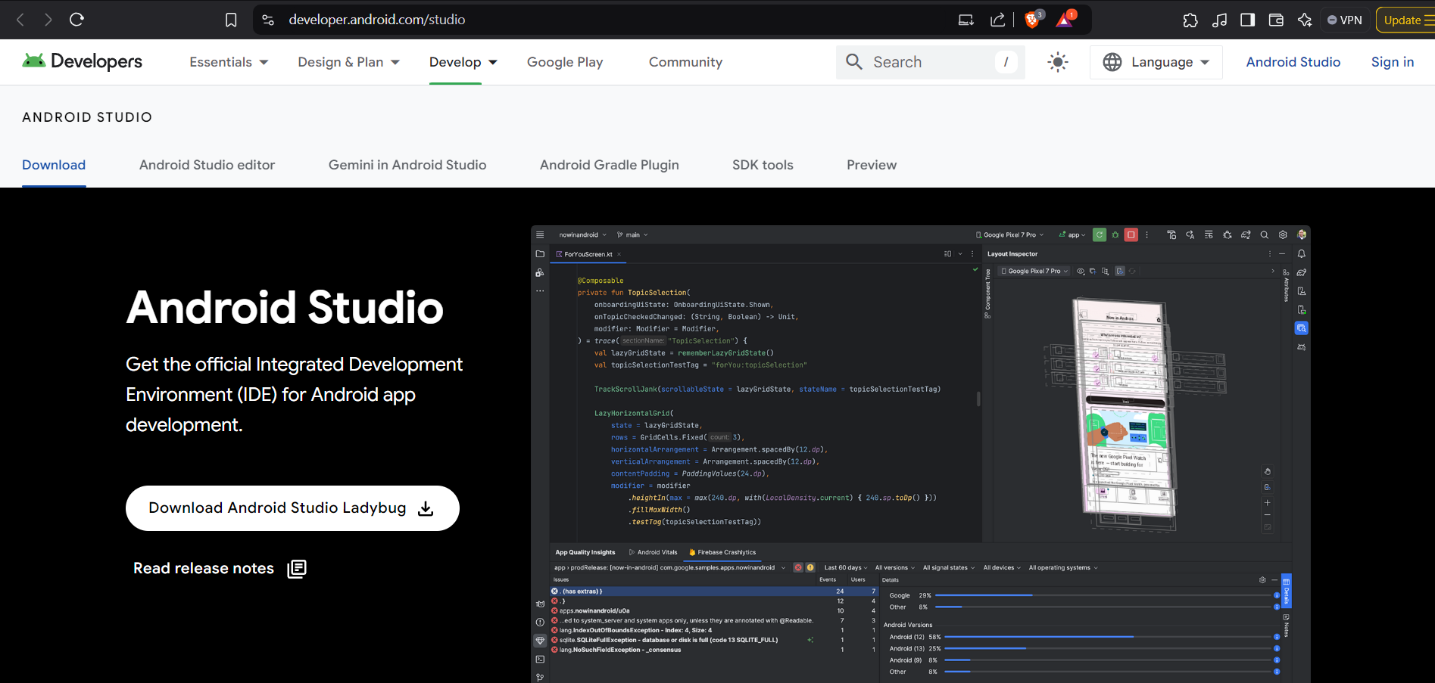

1. Install Flutter and Flutter Command Line Tools for Android Studio.

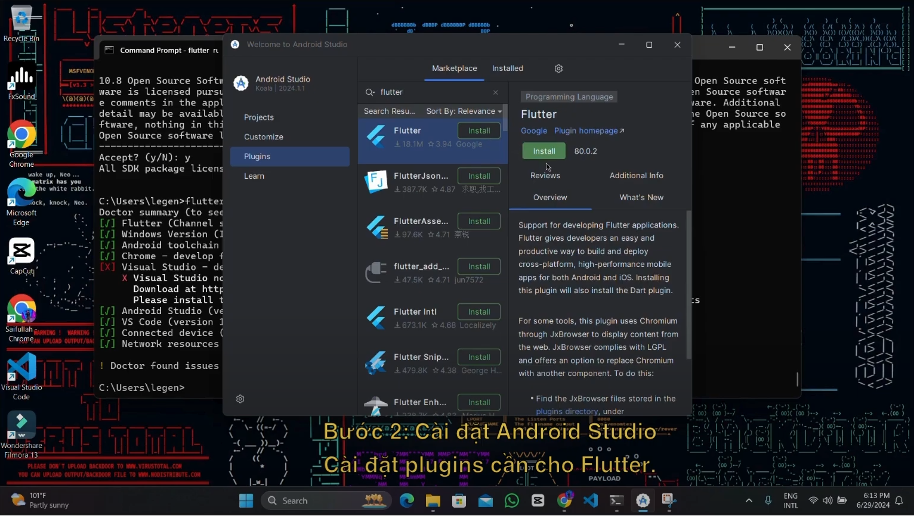

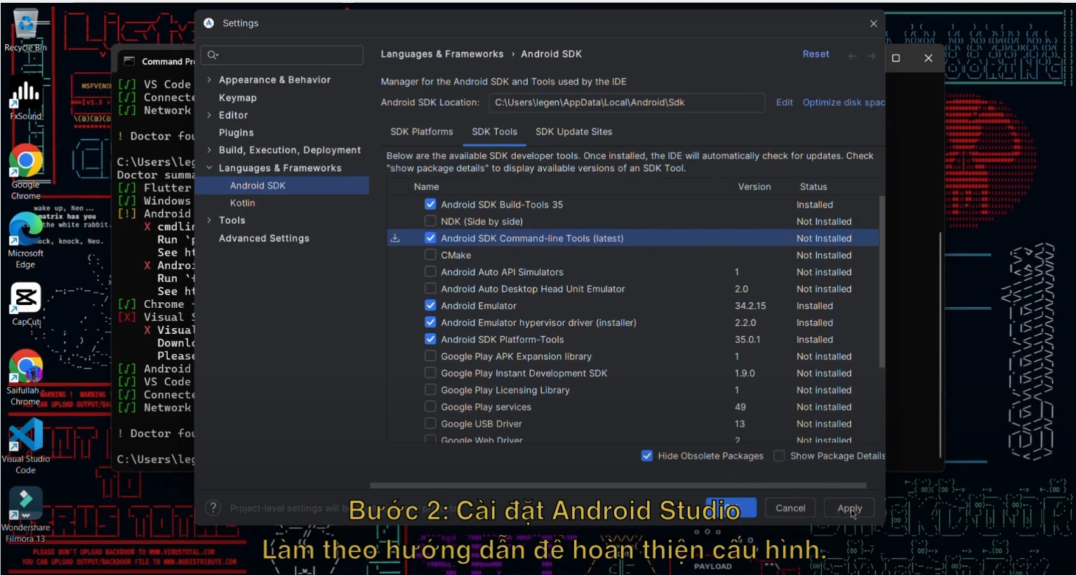

1. Install Android Studio emulator if needed.

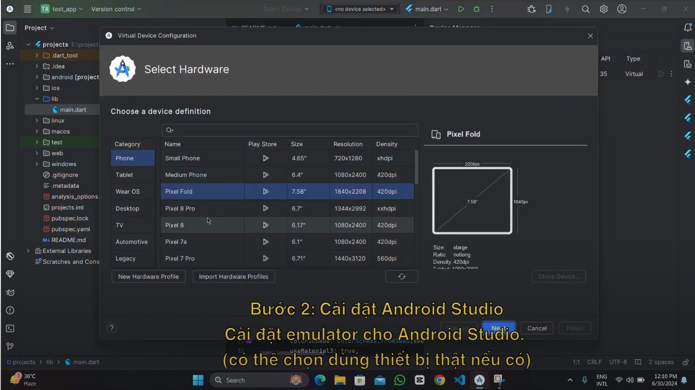

1. Configure Dart bin location for Android Studio.

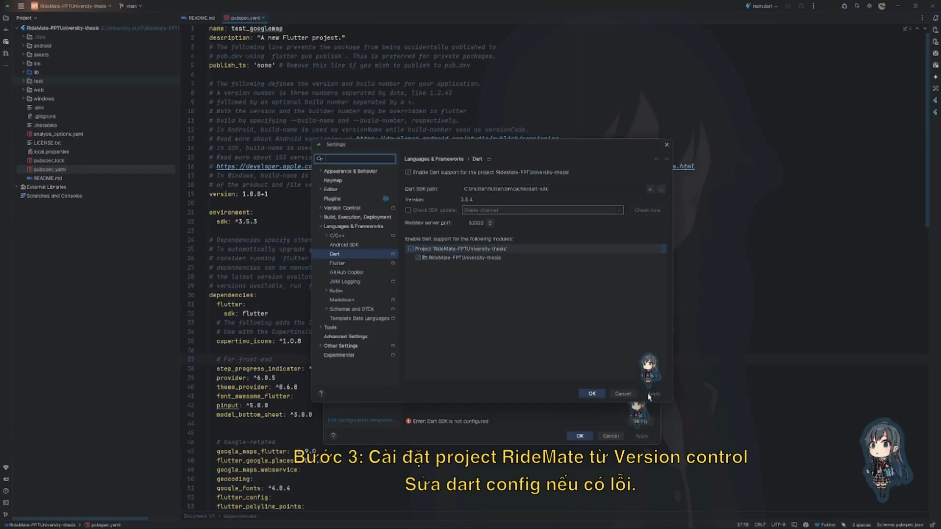

1. Pull Github repository: <https://github.com/khaikhaipq69/product_management.git>

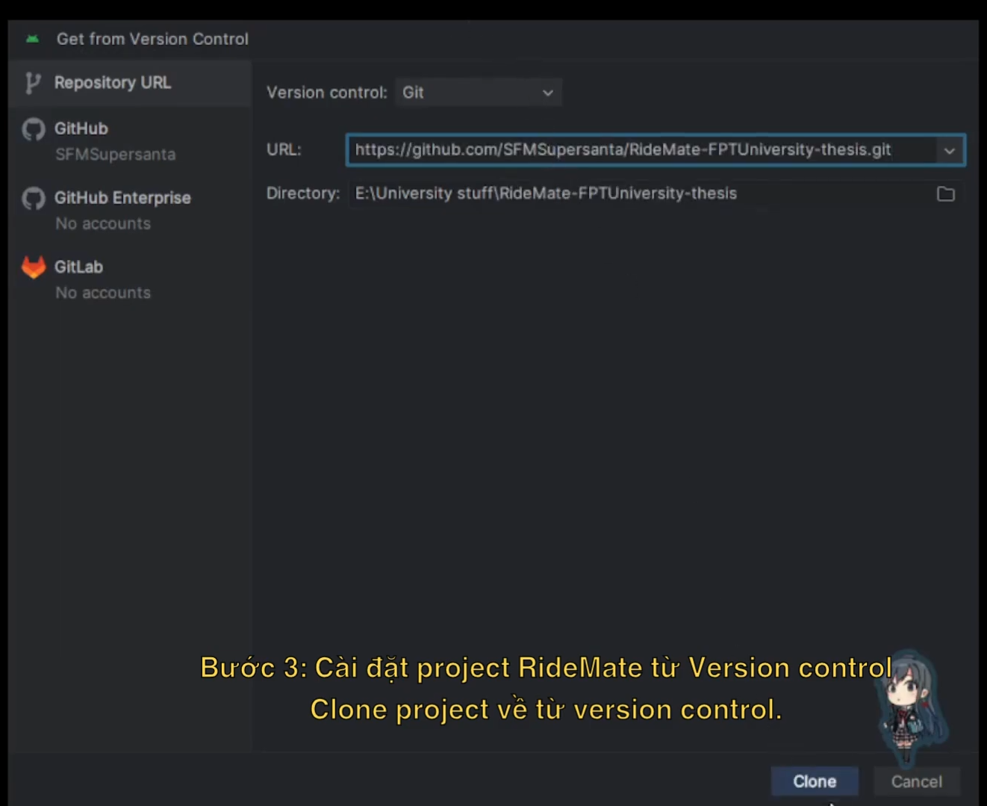

1. Run “pub get” from pubspec.yaml to get the required packages for the project.

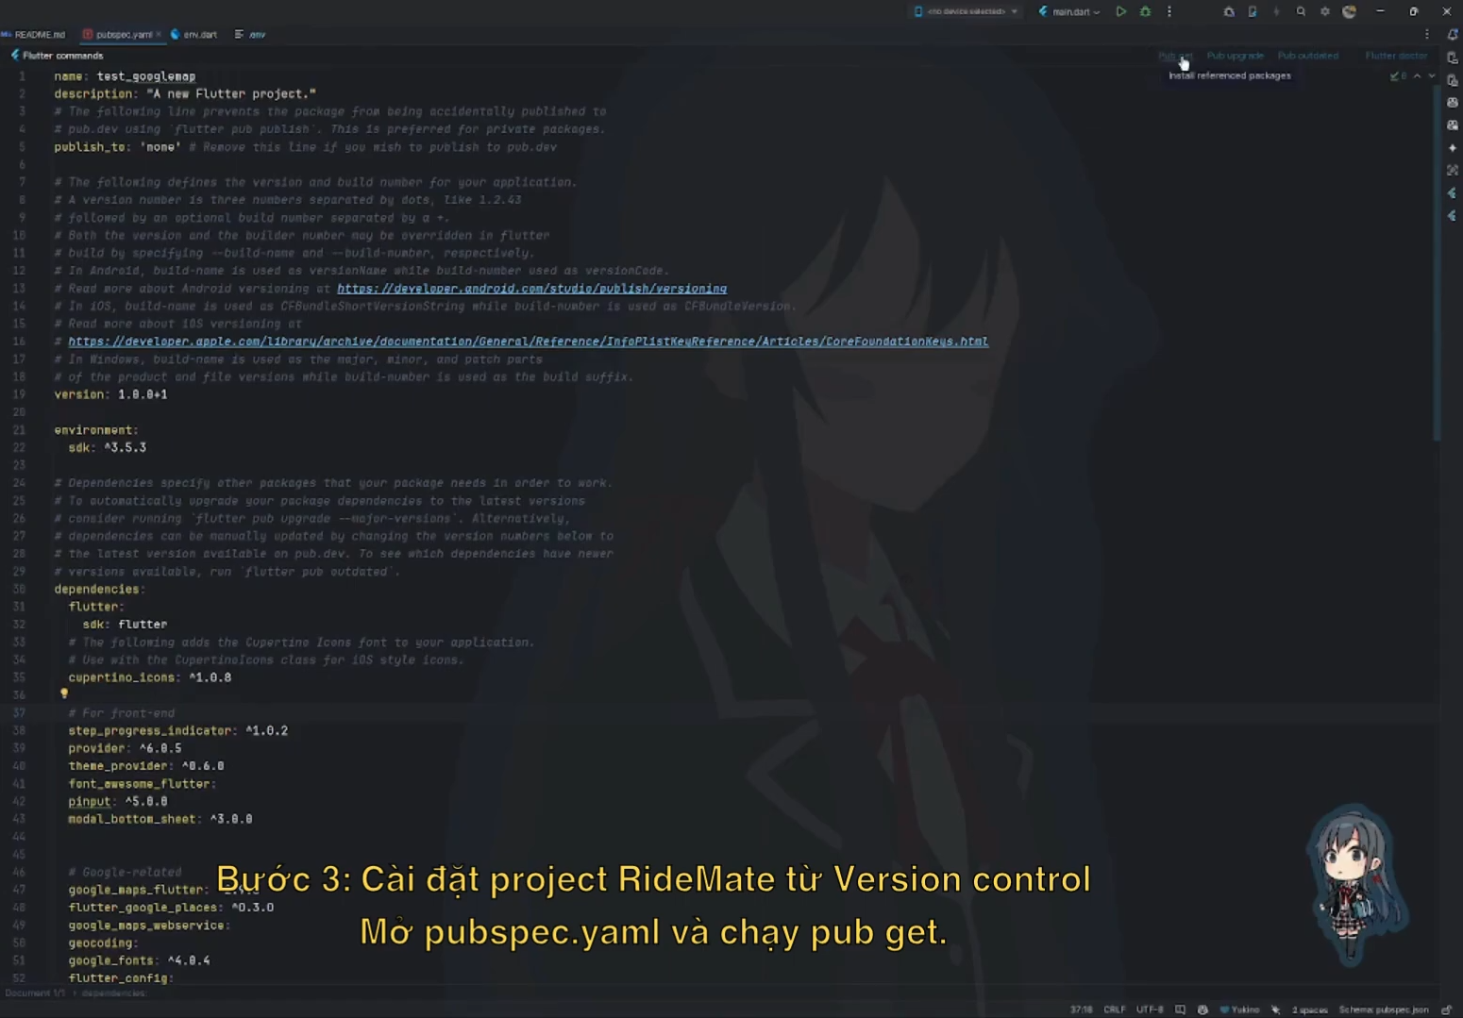

1. When the project is built successfully, a .apk file will be generated in *<project>/build/app/outputs/apk/debug/app-debug.apk*. Else you can use “flutter build apk --release” to get the release APK build in “build/app/outputs/flutter-apk/app-release.apk”.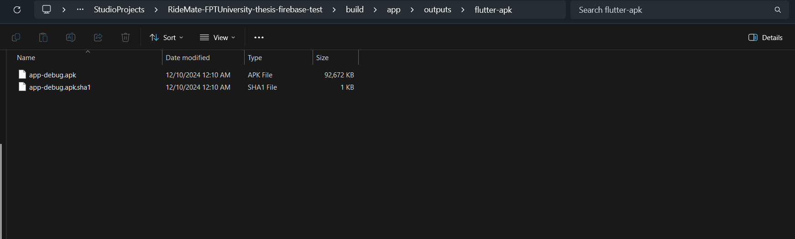

## 3. User Manual

### 3.1 Overview

* Here are the main features to help you understand how our app works.

#### 3.1.1. Create Product

This section explains how to add a new product to your product list.

Steps:

Navigate to the Home Screen: Upon opening the app, you will be directed to the home screen, which displays the product list and the product creation form at the top.

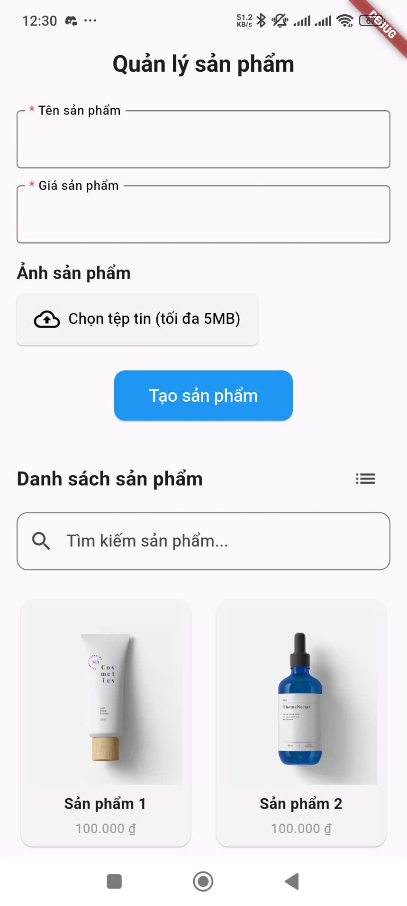

Enter Product Name: In the field labeled "Tên sản phẩm" (Product Name), tap on the text box and enter the name of your new product. This field is marked with an asterisk (*) indicating that it is required.

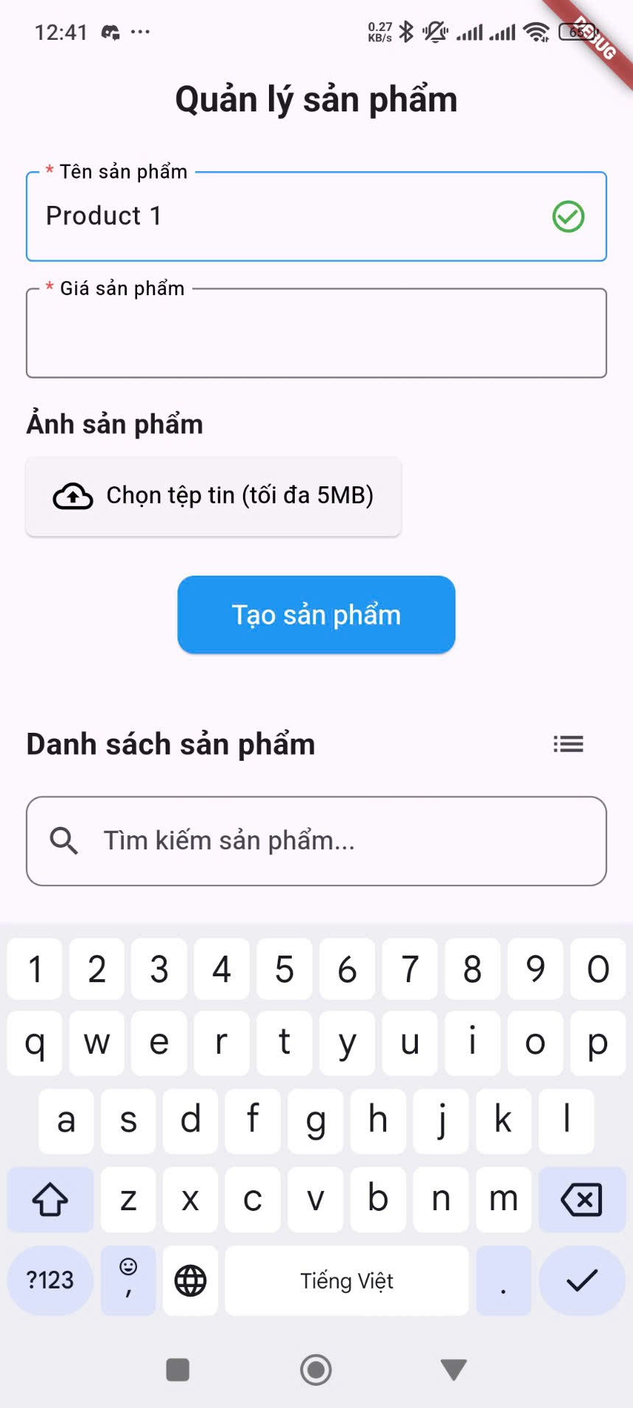

Enter Product Price: In the field labeled "Giá sản phẩm" (Product Price), tap on the text box and enter the price of your product. Please enter a valid number. This field is also marked with an asterisk (*) indicating that it is required.

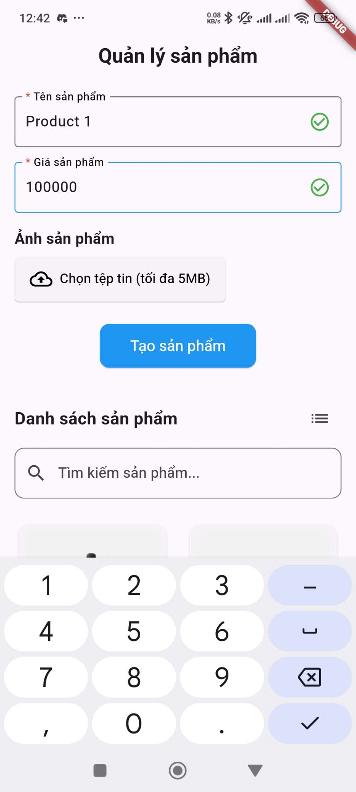

Note: The app may have validation rules for the price, such as minimum and maximum values. Ensure your entry falls within these limits if applicable.

Upload Product Image:

Tap on the "Chọn tệp tin (tối đa 5MB)" (Choose File (maximum 5MB)) button under the "Ảnh sản phẩm" (Product Image) section.

Your device's file explorer or gallery will open.

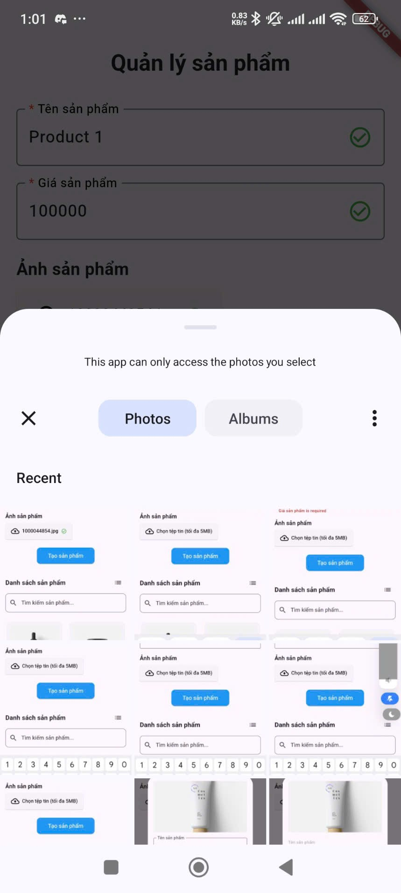

Browse and select the image you want to use for your product.

Once selected, the name of the image file will be displayed next to the button, along with a green checkmark icon indicating successful selection.

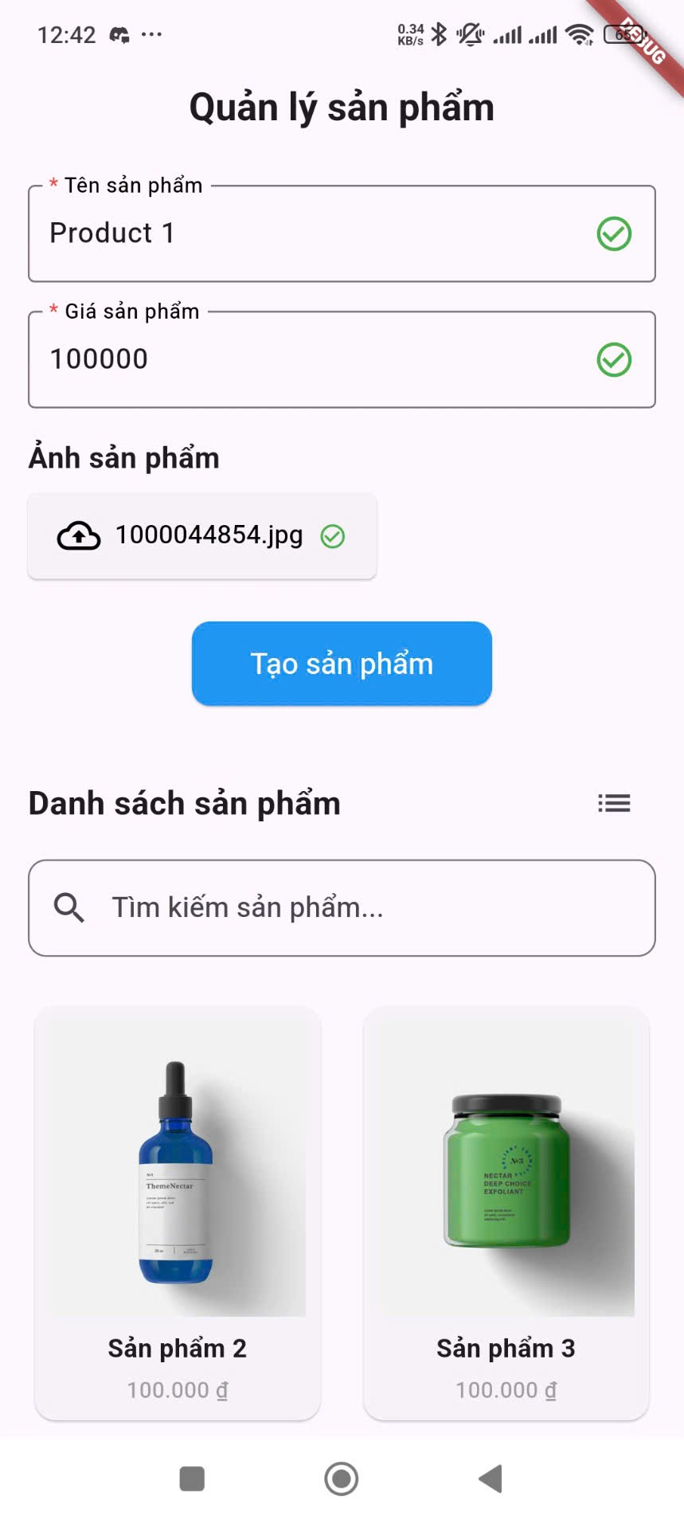

Note: The maximum file size for the image is 5MB. Only supported image formats (e.g., PNG, JPG) can be uploaded.

Submit Product Creation:

Once you have entered the product name, price, and selected an image, tap on the "Tạo sản phẩm" (Create Product) button located at the bottom of the form.

A confirmation message will briefly appear on the screen indicating whether the product was created successfully.

The newly created product will now appear at the top of the product list.

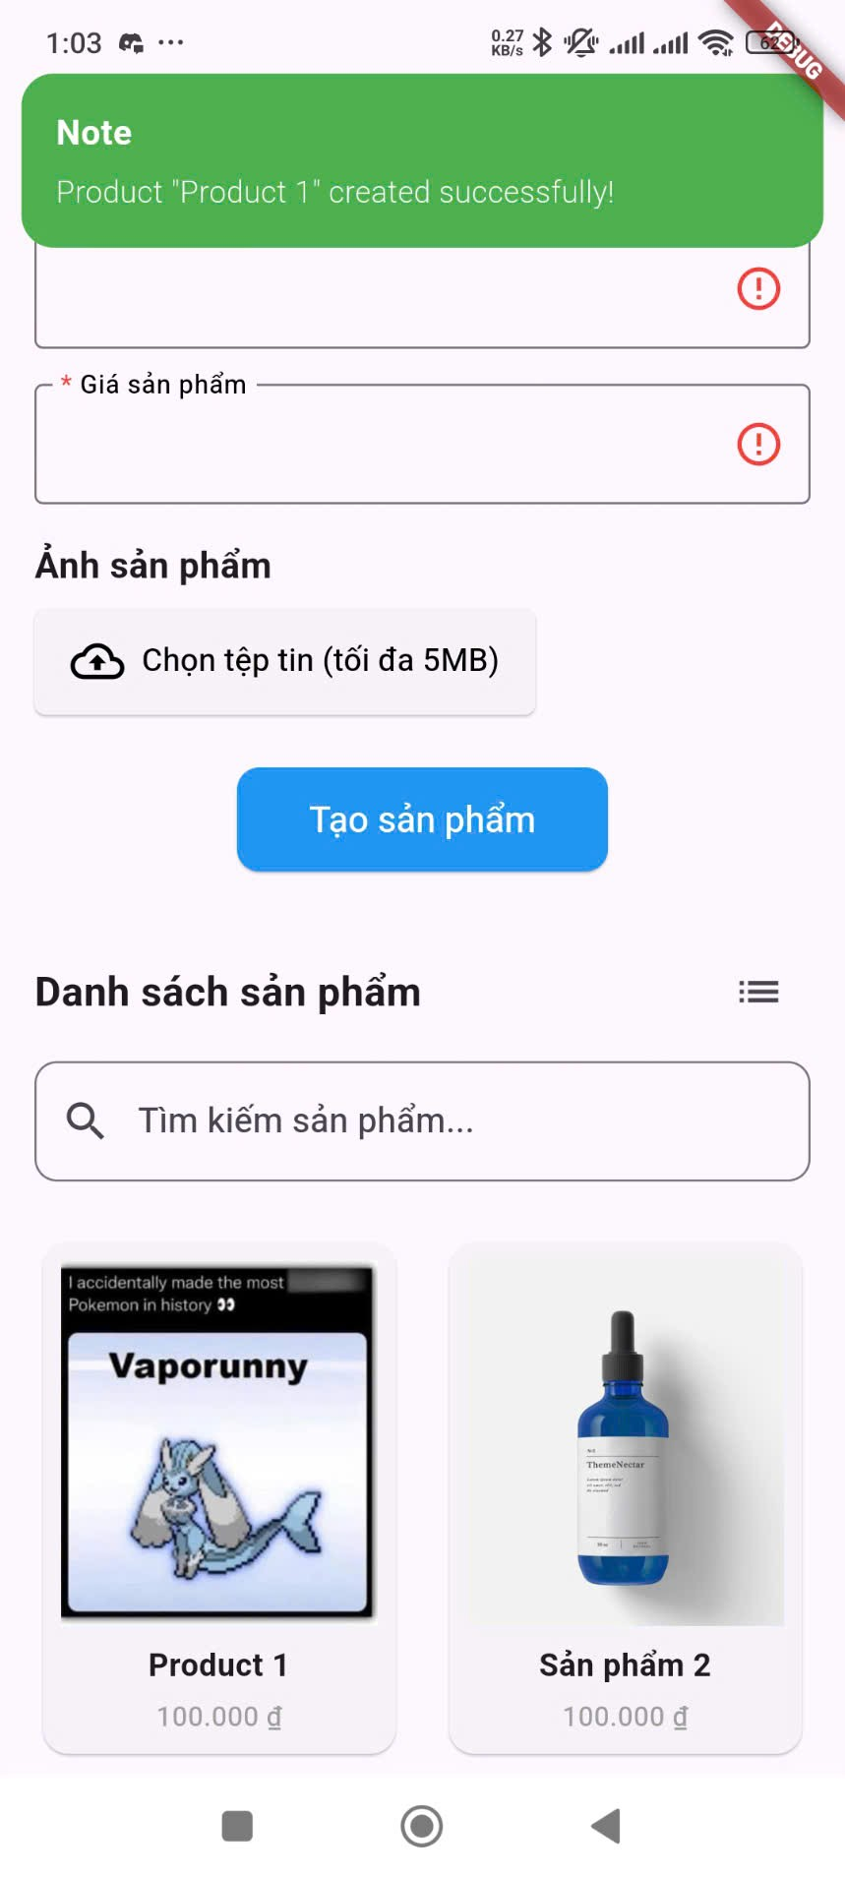

#### 3.1.2. View Product and View in Different Modes (Grid/List)

This section explains how to view your existing products in different layouts.

Viewing Products:

Upon opening the app, the main screen will display a list or grid of your products. Each product entry typically shows the product name and price. An image of the product may also be visible depending on the view mode.

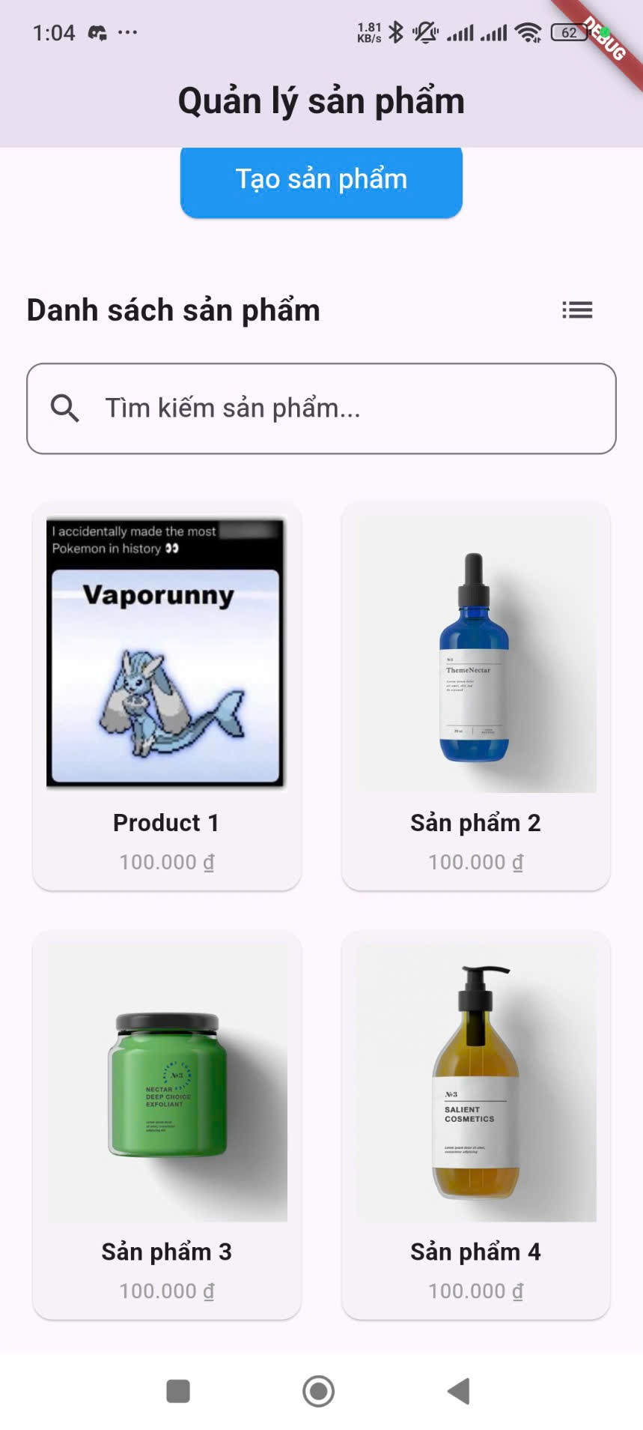

Switching Between Grid and List View:

Look for a view toggle icon (e.g., a grid icon or a list icon) usually located in the top right corner of the product list section.

To view products in a Grid layout: Tap on the grid view icon. Products will be displayed in a tile format, often showing the product image, name, and price.

To view products in a List layout: Tap on the list view icon. Products will be displayed in a vertical list, typically showing the product image (smaller), name, and price on each row.

The app will remember your last selected view mode for future use.

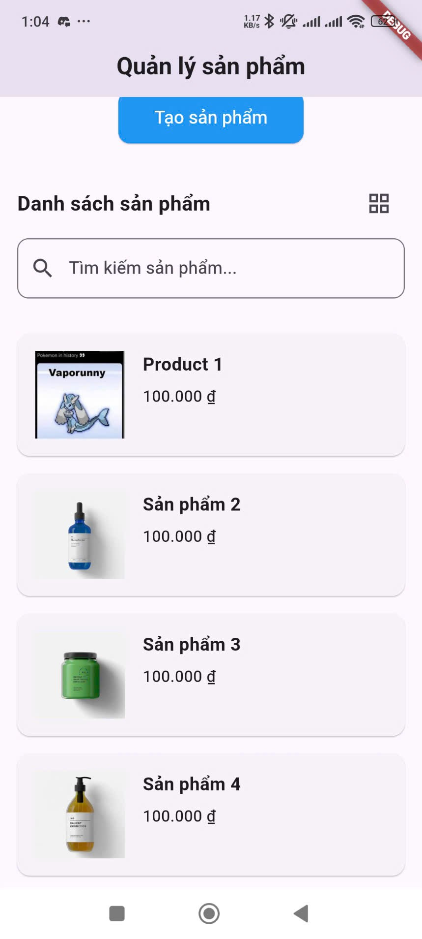

#### 3.1.3. Search Product

This section explains how to find specific products within your product list.

Steps:

Locate the Search Bar: On the home screen, look for a search bar, usually located at the top of the product list section. It might be labeled "Tìm kiếm" (Search) or have a magnifying glass icon.

Enter Search Term: Tap on the search bar and enter the name or keywords related to the product you are looking for.

View Search Results: As you type, the product list will automatically update to display only the products that match your search term.

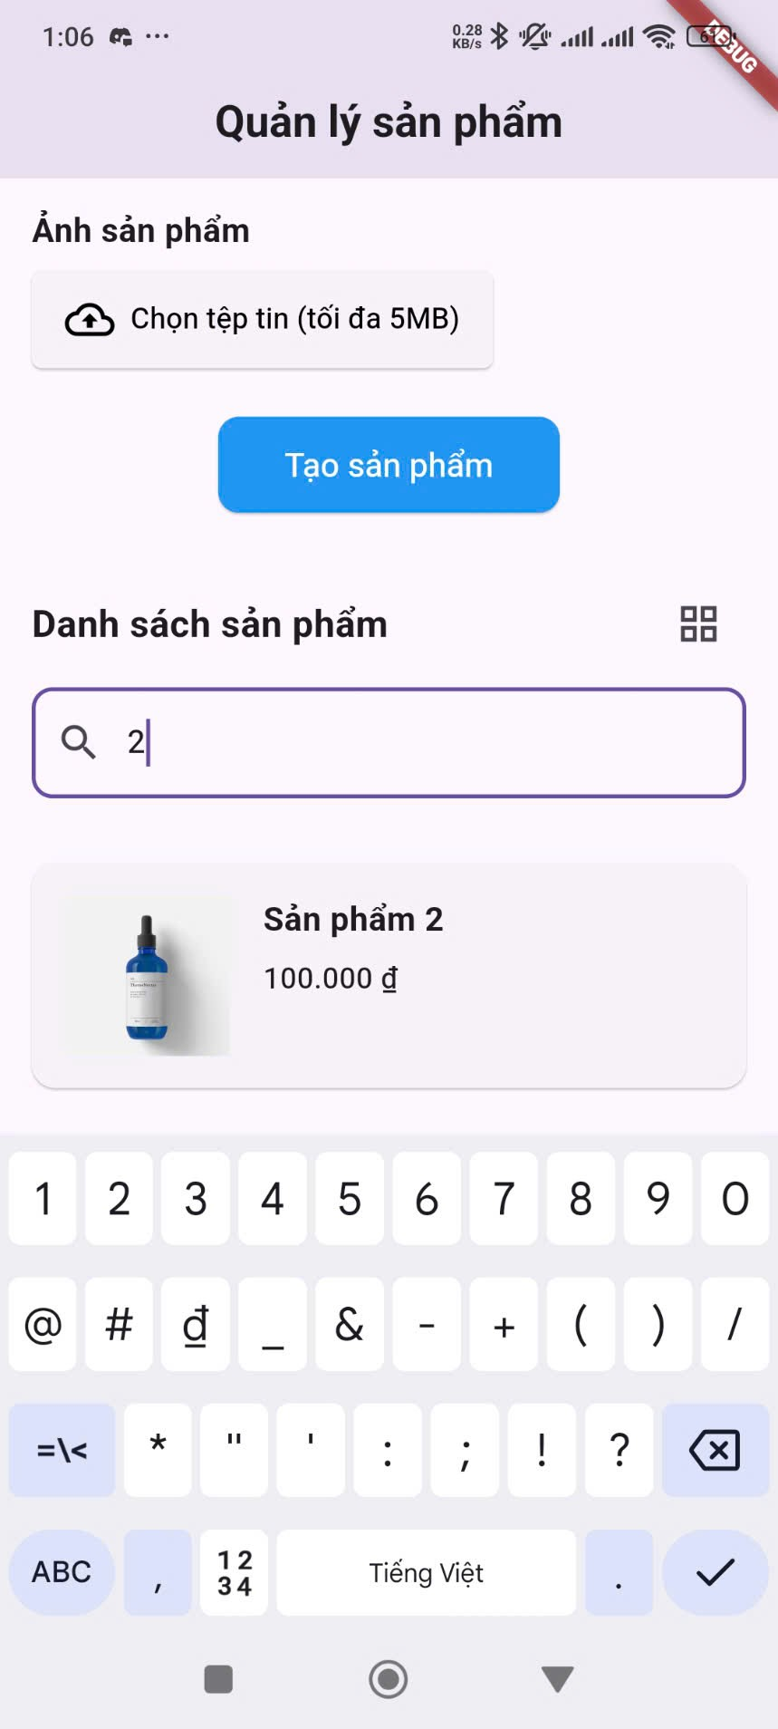

#### 3.1.4. Product Details

This section explains how to view detailed information about a specific product.

Steps:

Locate the Product: On the product list (either in grid or list view), find the product you want to view details for.

Tap on the Product: Tap anywhere on the product entry in the list or grid.

View Product Details: A pop-up window will appear displaying detailed information about the selected product. This typically includes:

A larger view of the product image.

The full product name.

The product price (formatted with the Vietnamese Dong symbol "₫").

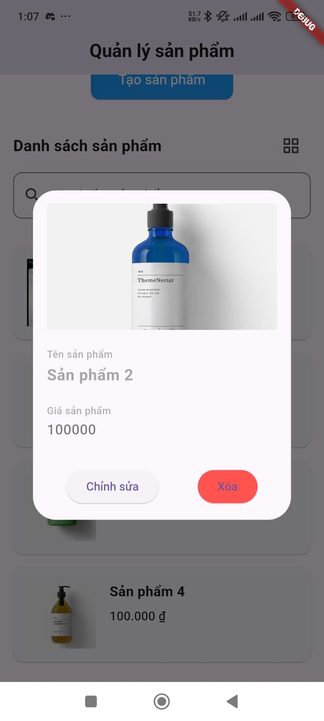

#### 3.1.5. Edit/Delete Product

This section explains how to modify or remove existing products from your inventory, accessed through the Product Details pop-up.

Accessing Edit/Delete Options:

View Product Details: Follow the steps in Section 4 to open the Product Details pop-up for the product you wish to edit or delete.

Locate Edit and Delete Buttons: Within the Product Details pop-up, you will find two buttons at the bottom:

Chỉnh sửa (Edit): Usually located on the left.

Xóa (Delete): Usually located on the right and may be styled with a different color (e.g., yellow or red).

Editing a Product:

Tap "Chỉnh sửa" (Edit): Tap on the "Chỉnh sửa" button.

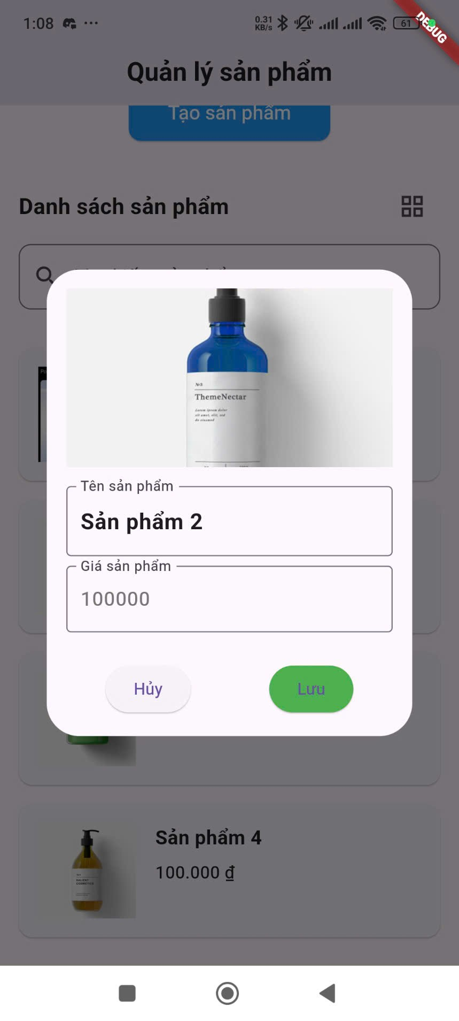

Edit Product Information: The product name and price fields in the pop-up will become editable.

Tap on the "Tên sản phẩm" field to modify the product name. Ensure you adhere to any length or format requirements.

Tap on the "Giá sản phẩm" field to change the product price. Enter a valid number within any specified range.

Save Changes: The "Xóa" button on the right will now change to "Lưu" (Save) and its color may change (e.g., to green). Tap on the "Lưu" button to save your changes. A confirmation message will appear, and the product details in the list will be updated.

Cancel Editing: If you decide not to make any changes, tap on the "Hủy" (Cancel) button that replaces the "Chỉnh sửa" button. The fields will revert to their original values.

Deleting a Product:

Tap "Xóa" (Delete): In the Product Details pop-up, tap on the "Xóa" button.

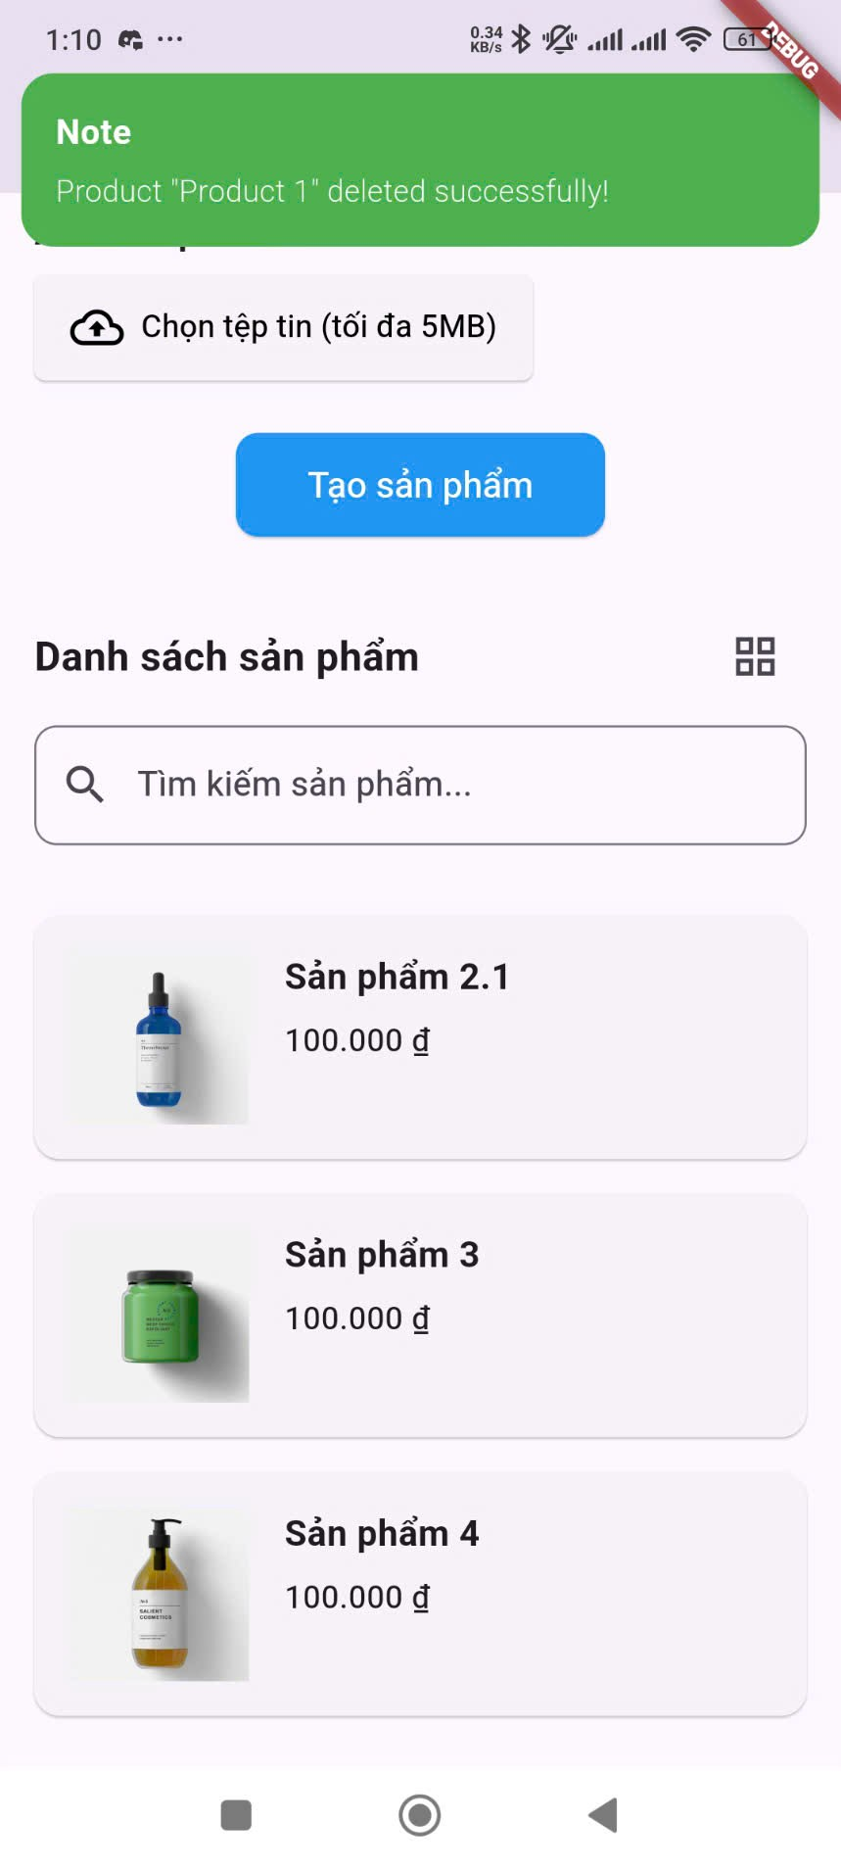

This user manual should help you navigate and use the key features of the QLSP product management application. If you encounter any issues or have further questions, please refer to the in-app help or contact support.